Control System for Wire-EDM: Development and Simulations of model for a simple WEDM system

Prakhar Diwan

Guide: Prof. S. V. Kulkarni Makarand Kane

1. Introduction

The main motive of the project was to improve the efficiency of slicing silicon into wafers by reducing the amount of silicon wasted in traditional methods such as diamond saw cutting method and wire loose slurry method.

Wire EDM was initially used only in the application of cutting conducting materials like metals. In this project, Wire EDM is being used for slicing silicon, which is a semiconductor.

My work was to design and simulate the control system model of WEDM, which I have executed with the help of Simulink.

|  |  |  |  |
| --- | --- | --- | --- |
| Name | Meaning | Name | Meaning |
| ediff | Gap Width | z | Increment in gap width |
| Vsp | Spark Voltage | Vol | Volume of the material removed |
| Isp | Spark Current | mm_dis | Unit step of Micromotion Controller |
| Ae | Area of the Electrode | w | Radius of the wire |
| hp | Height of workpiece | Vgap | Gap Voltage |
| td | Ignition time delay | tsp | Spark time |
| Vfilt | Filtered Voltage | Tm | Time period of the voltage pulse |
| x | Position of the electrode | MRR | Material Removal Rate |
| SV | Reference Servo Voltage | SVoffset | Reference Servo Voltage offset |

1. Wire Electrical Discharge Machining (WEDM) controls system

A table-top WEDM system is already designed and developed in Insulation Diagnostics Lab, EE Dept, IIT Bombay. A simple first order model of the system is made and simulated in MATLAB Simulink.

The model consists of the following subsystems:

* EDM Process
* EDM Pulse generator
* EDM Servo system

The simulations were performed for the WEDM system which consisted of rheostat, which depicted the variable resistance of the gap between the wire and the workpiece. This gap is continuously flushed by or immersed in a dielectric fluid.

1. EDM Process Model

EDM process model has following three inputs

1. Spark voltage
2. Spark current
3. Old Position of the wire

The model involves the calculation of material removal rate via the energy method. This material removal rate is then integrated over a time period to give the volume of material removed. This volume is then divided by the area of electrode to get the increment in gap width. This is then used to update the value of gap width for the next iteration.

The equations involved in the subsystem are as follows:

$$\int_{0}^{T_{o}}{V_{sp}I_{sp}dt}=\frac{1}{E_{const}}×\frac{dVol}{dt}$$

$$\int_{0}^{T1}{\frac{dVol}{dt}=Ae×z}$$

$$Ae=2π×\left(w+ediff\right)×hp$$

The EDM Process subsystem developed is as follows: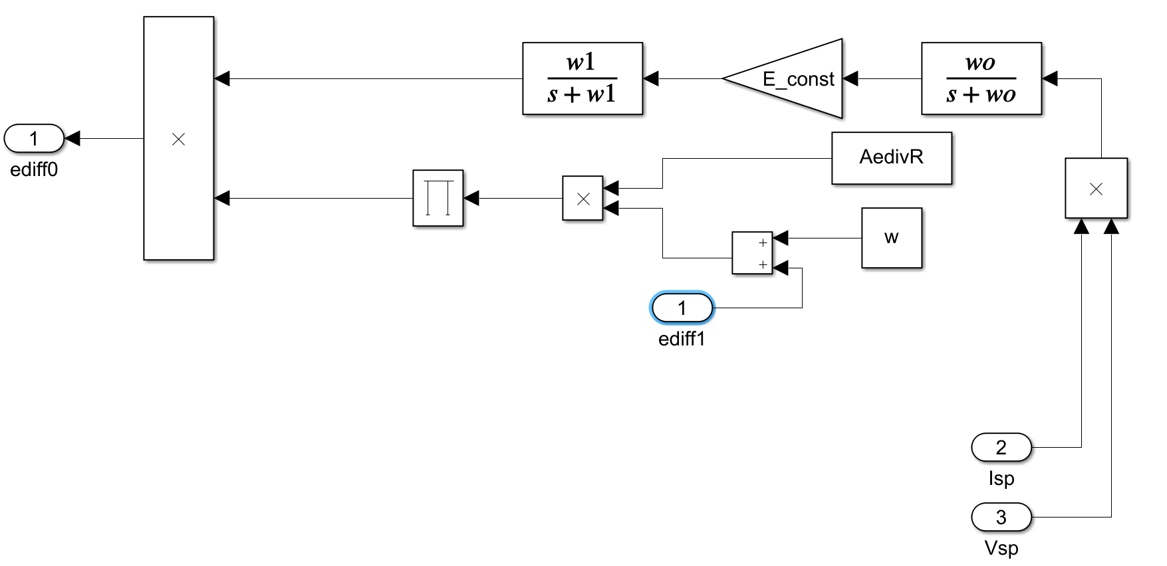

There are three input signals: Spark Voltage, Spark Current and gap width (ediff1). The output signal is the gap width increment (ediff0). A feedback loop is formed outside the subsystem with the signals ediff0, ediff1, mm_dis (displacement of the wire electrode) and the operators: adder and a subtractor. The simulations for Material Removal Rate and position are shown in Fig(1).

The equation for the filter is as follows:

$$Vfilt\left(s\right)=\frac{1}{To*s+1}*Vsp\left(s\right)$$

1. EDM Pulse generator

The pulse generator may contain any power electronic circuit whose voltage and current are usually controlled by the operator. The pulse generator is represented by the following circuit. It takes reference voltage, reference current and pulse repetition frequency as the input and gives out pulsed voltage as the output. The subsystem is as follows:

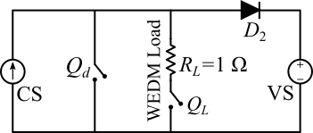

The phases of the voltage across EDM for different times are as shown:

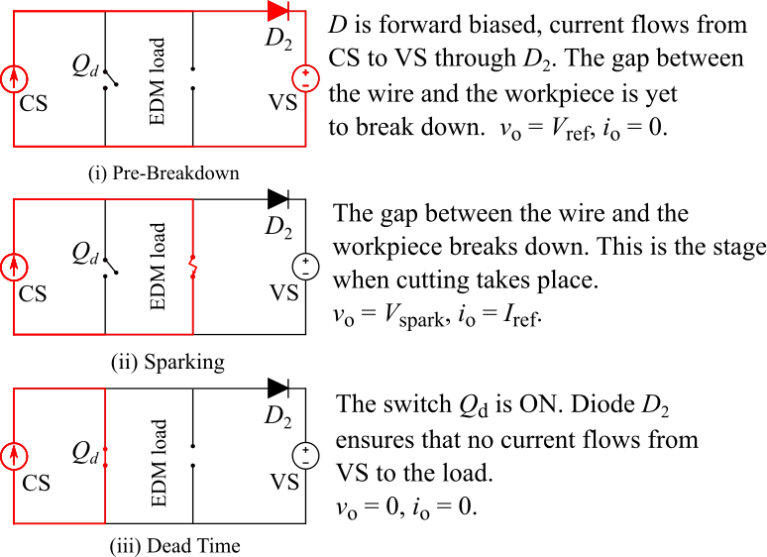

The simulations for the voltage and current pulses are plotted with MRR in Fig(2).

1. EDM Servo system

EDM servo system consists of Holmarc translation stages HSMC480 which controls motion of X-Y translation stages. When a pulsed voltage is applied across the load, the voltage reduces. When the sparking does not happen, the average voltage is more. At that time the controller should send a triggering signal to move the electrode ahead.

$${\left.{ AVG(V}_{gap})\right|}_{sparking}=\frac{V_{ref}t_{d}+V_{sp}t_{sp}}{T_{m}}$$

$${\left.{ AVG(V}_{gap})\right|}_{open}=\frac{V_{ref}t_{ON}}{T_{m}}$$

The system’s logic is depicted as follows:

Vfilt

0<Vfilt<=SV-SVoffset

Vfilt>SV+SVoffest

YES NO NO YES

x = x + mm_dis

x = x - mm_dis

x = x

The subsystem was made in Simulink as follows:

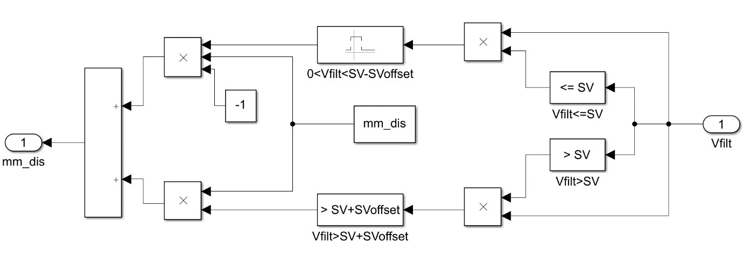

I encountered a bug in the simulation initially because of absence of the condition: Vfilt>0. Initially I was getting a zero as response to Vfilt > SV+SVoffest because the upper logic block of <=SV also gave a negative displacement signal, due to the Boolean false value (0), which counteracted the positive displacement signal given by the lower logic block. However, I was expecting a positive displacement. Then, I got this debugged with a new logical block as a replacement for the initial block.

The reason behind this type of motion for the wire is that as the wire gets away from the workpiece the gap resistance and the Vfilt increases, and the sparking does not occur with the pulses supplied, so we move the electrode closer to the workpiece by appositive displacement mm_dis. The other logic is vice-versa.

1. Simulations

The plots for simulations are as follows:

1. Material Removal Rate, Filtered Material Removal Rate, Position versus Time
2. Spark Voltage, Spark Current and Material Removal Rate versus Time

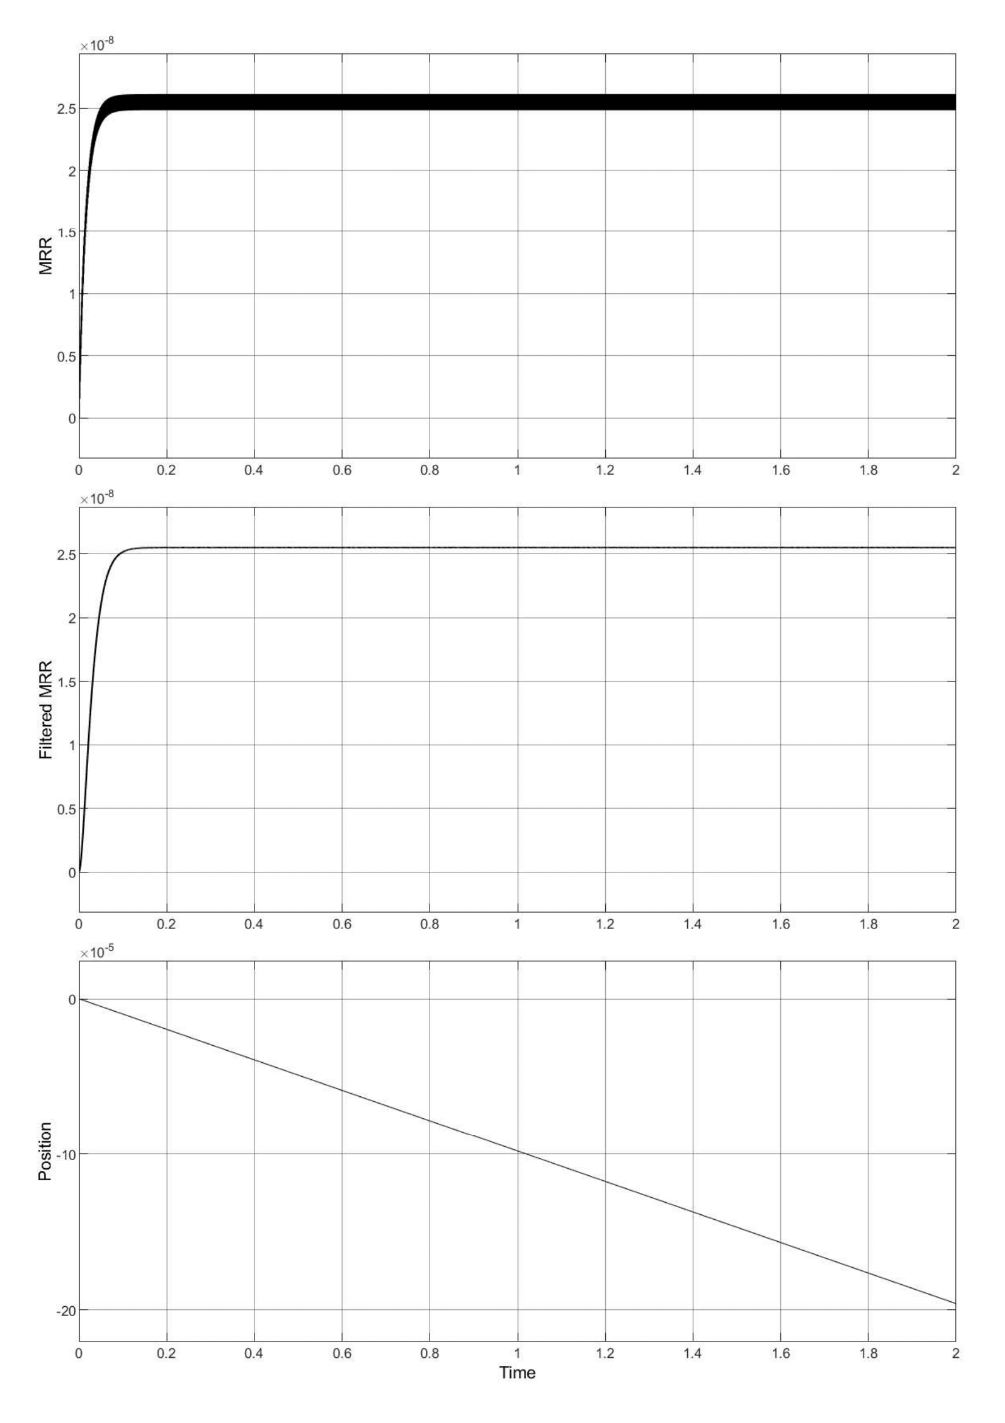

Fig(1)

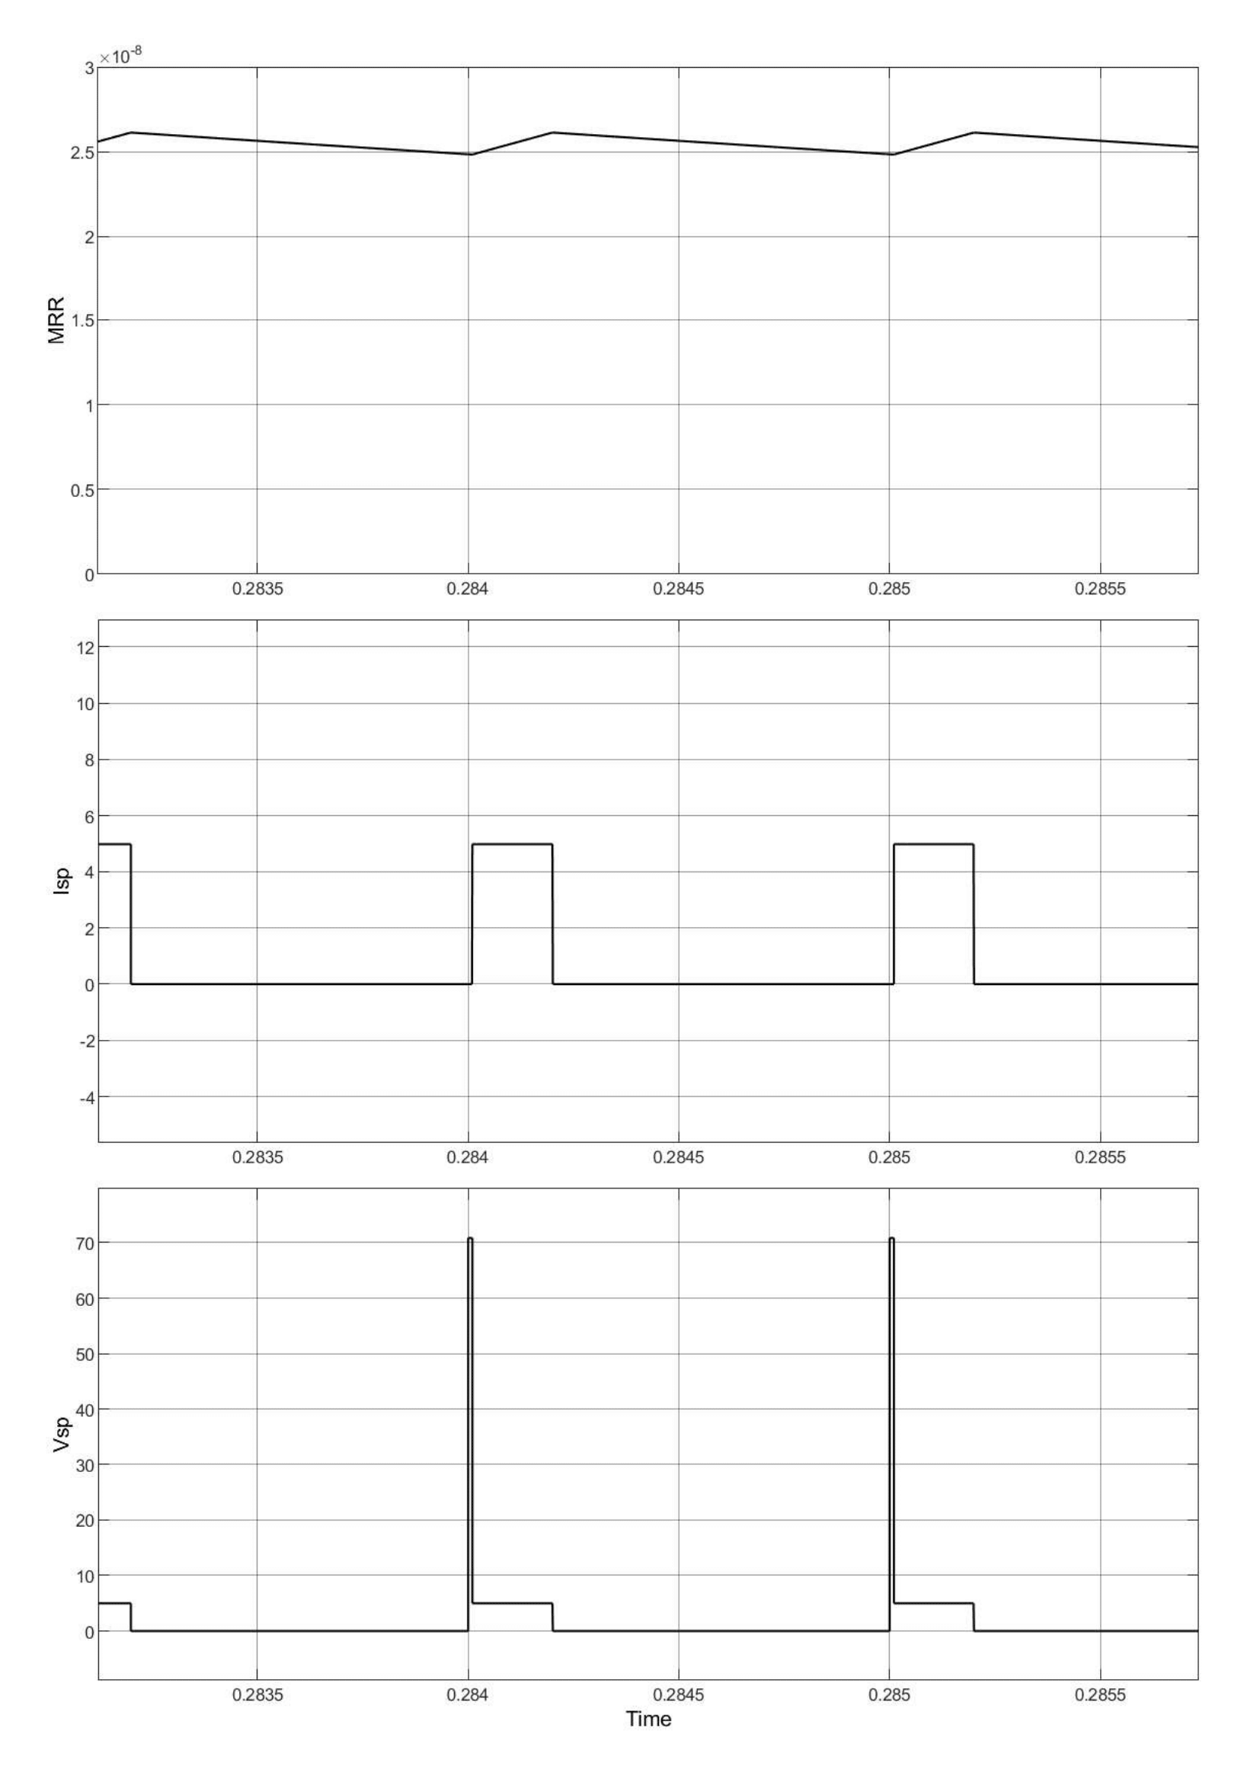

Fig(2)

1. Conclusion:

The simulation and development of a simple WEDM system was done. However, steady state error was observed in the material removal rate. Based upon the simulation of signals I concluded that Material Removal Rate saturated at a constant value after some time. Also, the position of the wire showed a straight line variation with time. The overall system looked as follows:

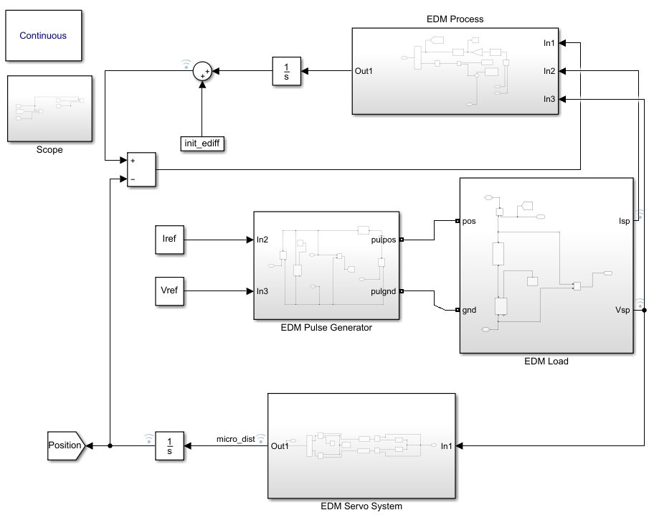

1. Limitations/ Future Scope

During the construction of this model, I made the assumption of half-cylindrical volume removal and also calculated the volume on the basis of thin sheet assumption i.e. by assuming that the material removed is a thin sheet. However, this is not a precise assumption when cutting a long distance. Also, an assumption of 180 degrees uniform deformation is taken. The ripples observed in the steady state Material Removal Rate are because of no equations accounting for inertia of the micromotion controller.

This is a simple model for WEDM and does not include the controls for maintaining the dielectric fluid flow, tension and speed of the wire. The model does not give variation in gap width as an input to the rheostat/ gap resistance. The resistance of the workpiece in case of silicon will also add to the gap resistance. This can be implemented in the model.

The last two limitations require the use of a modified EDM load which contains of a constant series resistance, depicting the addition of resistance due to silicon and a voltage-controlled rheostat which depends on the experimental plot of Voltage across EDM and the EDM voltage and Resistance of EDM load – Constant Resistance (Si).